Insert School Logo

Semester Two

Examination 2018

Question/Answer booklet

MATHEMATICS
SPECIALIST UNITS 3 & 4

Section Two:
Calculator-assumed

Student Name: _____________________________________

Teacher’s Name: _____________________________________

Time allowed for this section
Reading time before commencing work: ten minutes
Working time for paper: one hundred minutes

Material required/recommended for this section

To be provided by the supervisor

This Question/Answer booklet
Formula Sheet (retained from Section One)

To be provided by the candidate
Standard items: pens (blue/black preferred), pencils (including coloured), sharpener, correction tape/fluid, erasers, ruler, highlighters

Special Items: drawing instruments, templates, notes on two unfolded sheets of A4 paper,
and up to three calculators approved for use in the WACE examinations.

Important note to candidates
No other items may be taken into the examination room. It is your responsibility to ensure that you do not have any unauthorised notes or other items of a non-personal nature in the examination room. If you have any unauthorised material with you, hand it to the supervisor before reading any further.

Structure of this paper

 | Number of questions available | Number of questions to be attempted | Working time (minutes) | Marks available | Percentage of exam
Section One  Calculator—free | 7 | 7 | 50 | 50 | 35
Section Two  Calculator—assumed | 10 | 10 | 100 | 100 | 65
 |  |  |  |  | 100

Instructions to candidates

- The rules for the conduct of Western Australian external examinations are detailed in the
Year 12 Information Handbook 2018. Sitting this examination implies that you agree to abide by these rules.

- Answer the questions according to the following instructions.

Show all your working clearly. Your working should be in sufficient detail to allow your
answers to be checked readily and for marks to be awarded for reasoning. Incorrect answers given without supporting reasoning cannot be allocated any marks. For any question or part question worth more than two marks, valid working or justification is required to receive full marks. If you repeat an answer to any question, ensure that you cancel the answer you do not wish to have marked.

It is recommended that you do not use pencil, except in diagrams.

- You must be careful to confine your responses to the specific questions asked and to follow any instructions that are specific to a particular question.

- Spare pages are included at the end of this booklet. They can be used for planning your responses and/or as additional space if required to continue an answer.
- Planning: If you use the spare pages for planning, indicate this clearly at the top of the page.
- Continuing an answer: If you need to use the space to continue an answer, indicate in the original answer space where the answer is continued, i.e. give the page number. Fill in the number of the question that you are continuing to answer at the top of the page.

- The Formula Sheet is not handed in with your Question/Answer Booklet.

Section Two: Calculator–assumed 65% (100 marks)

This section has ten (10) questions. Attempt all questions. Write your answers in the spaces
provided.

Working time: 100 minutes

Question 8 (5 marks)

A first order differential equation has a slope field as shown in the diagram below.

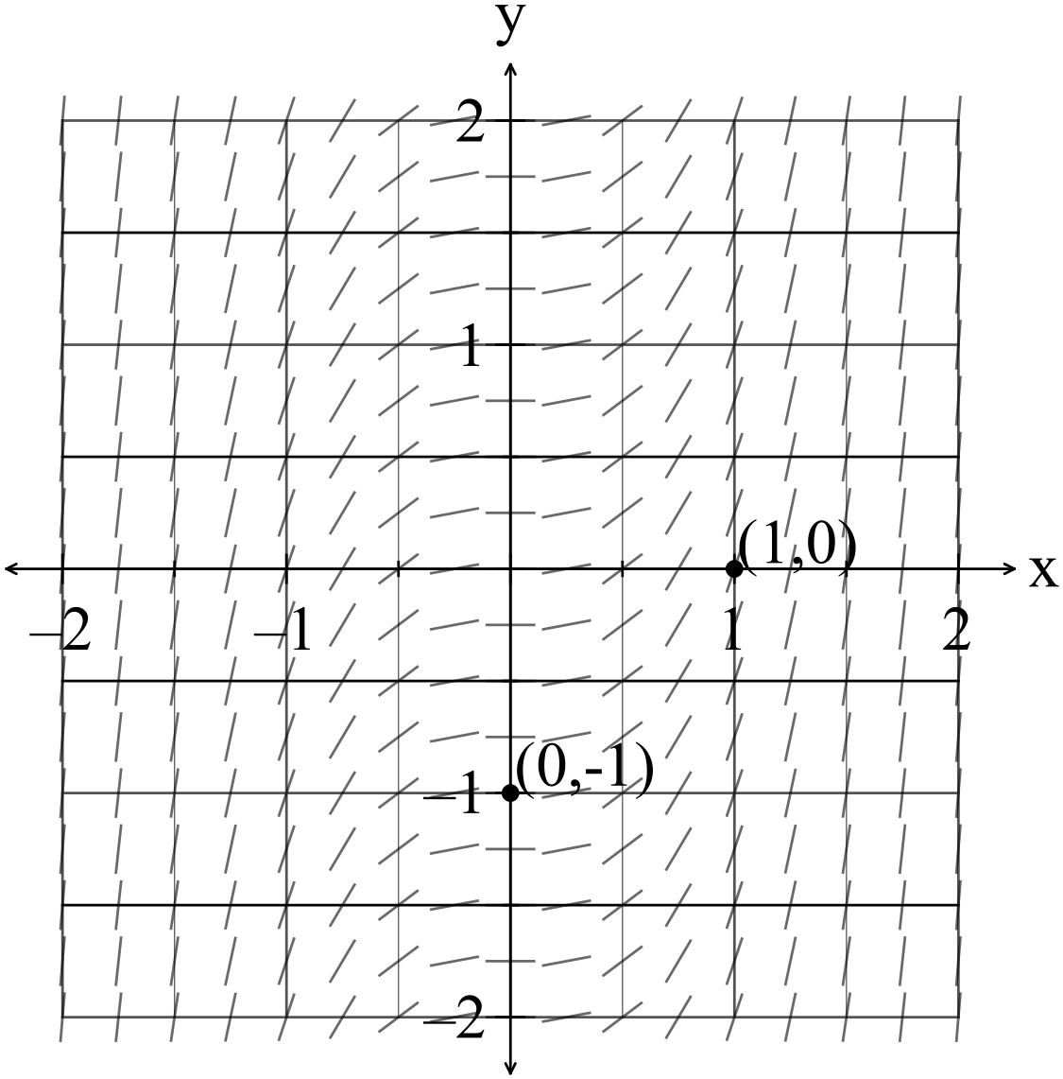

(a) Determine a general differential equation that is represented by this slope field. (2 marks)

(b) Find the unique solution to the differential equation in (a) given that the points (1,0) and (0, -1) belong to the curve. (3 marks)

Question 9 (6 marks)

(a) Define the region defined by the shaded region on the complex plane in the diagram below.
(4 marks)

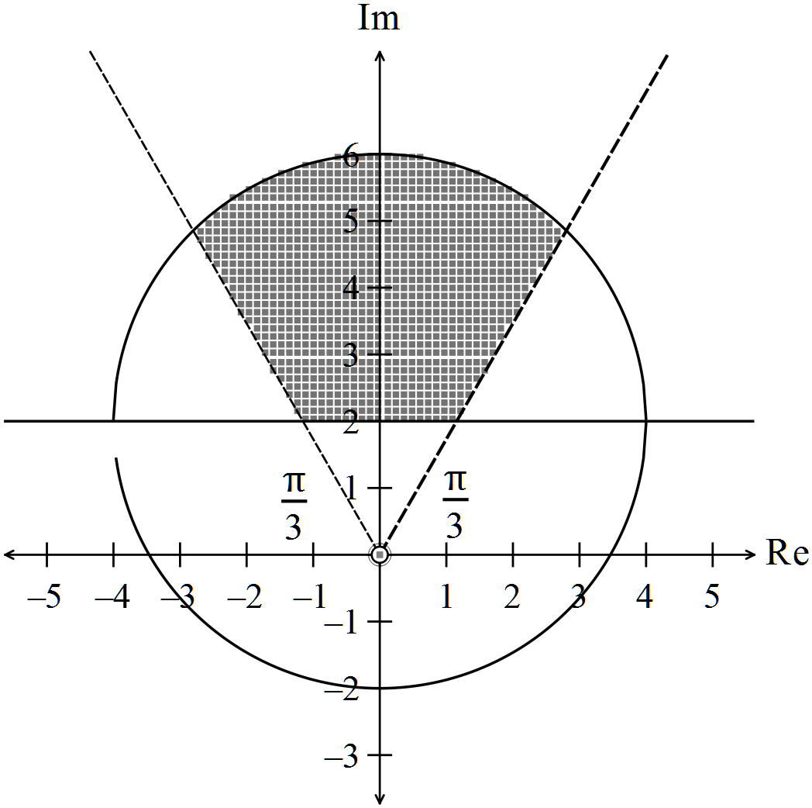

(b) Find such that the expression is real, for (2 marks)

Question 10 (10 marks)

The position vector of a particle P s given by the equation
The path of P is shown on the graph below.

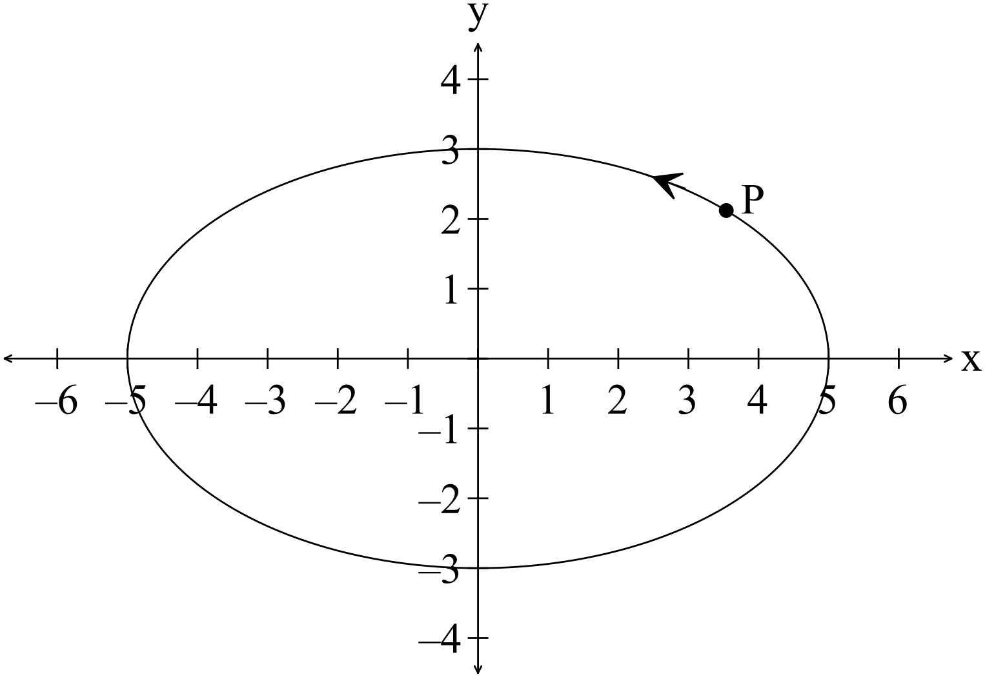

(a) Determine the Cartesian equation of the path. (2 marks)

(b) Determine expressions for the velocityand the acceleration of P, in terms of t.
(2 marks)

(c) Plot the velocity vector and the acceleration vector at on the diagram below. (3 marks)

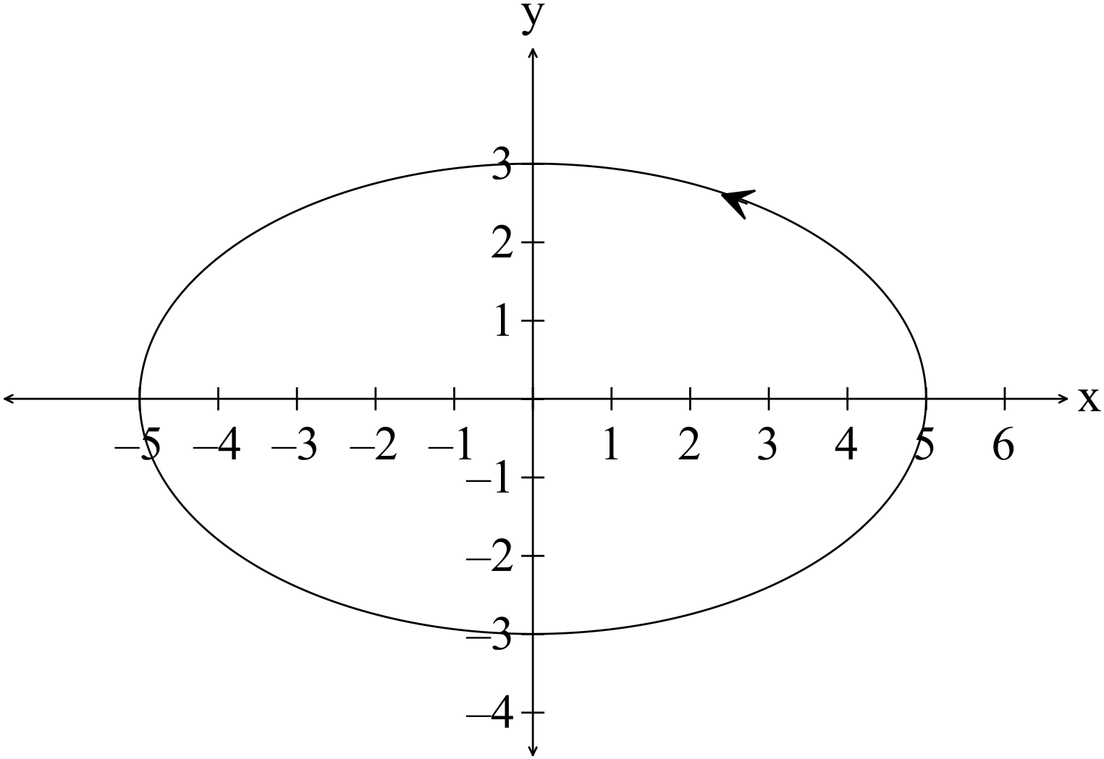

(d) The displacement vector is perpendicular to the velocity vector at
Determine the next time the displacement vector is perpendicular to the velocity vector.
(3 marks)

Question 11 (7 marks)

(a) Determine the area between between two consecutive intersections of the functions.
(3 marks)

(b) Find the expression that if evaluated represents the shaded area in the diagram below.
(Do not evaluate the expression.) (4 marks)

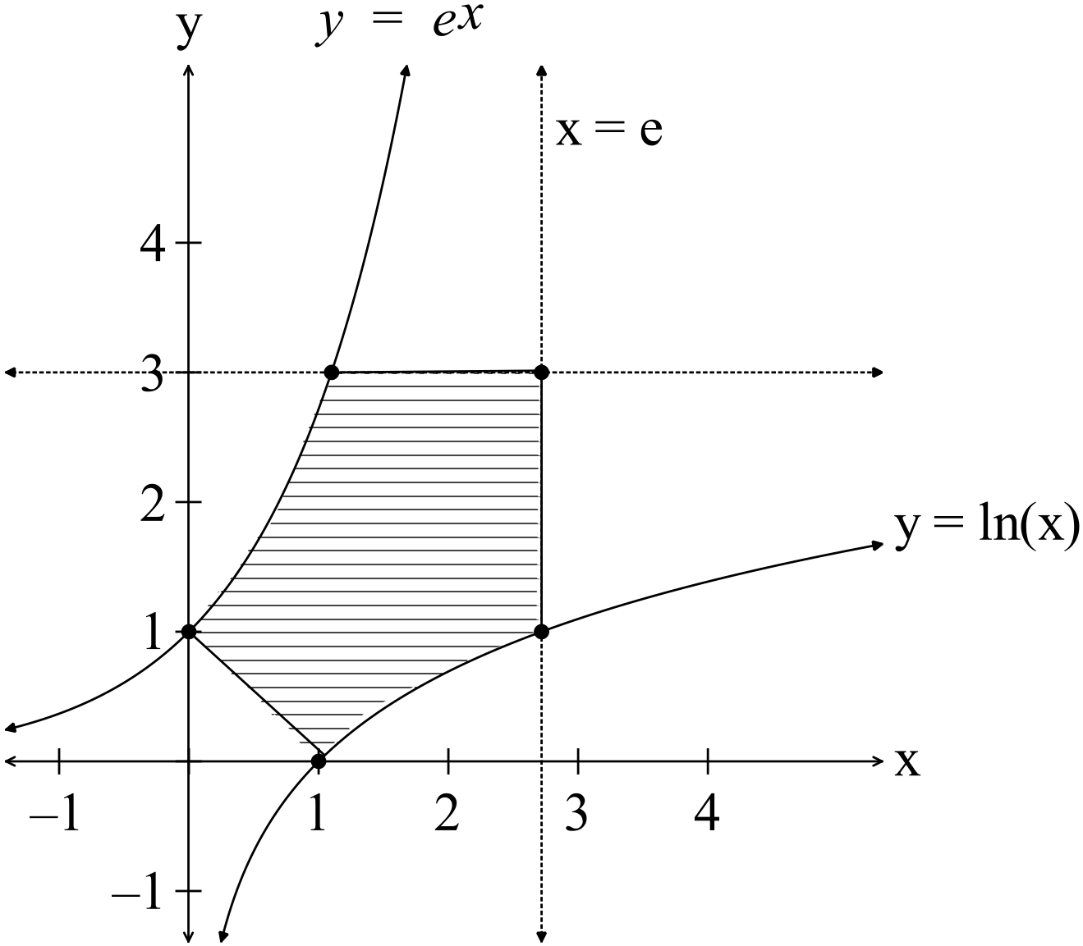

Question 12 (10 marks)

(a) A sphere has a radius of 50 cm. Use a Calculus method to determine the increase in the volume of the sphere if the radius is increased by 0.1 cm. (3 marks)

(b) Water is being poured into a hemispherical vase at a rate of 25 cm³sec⁻¹.The radius of the vase is 50 cm and the height of the water is h.

(i) Show that the expression for the volume of water in the vase can be given by (3 marks)
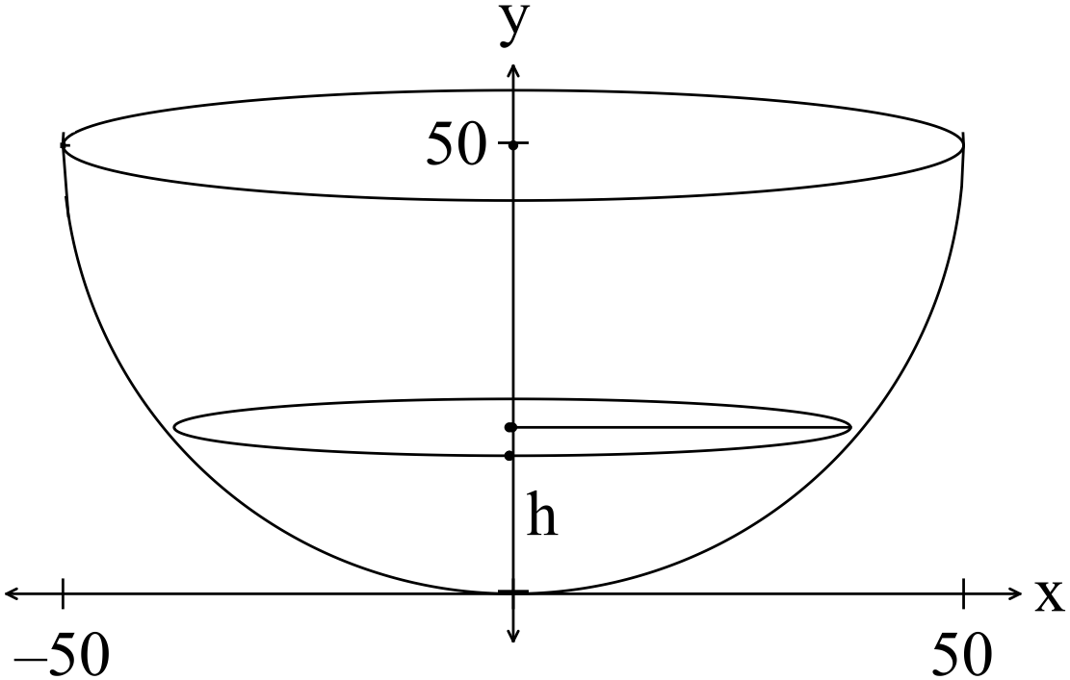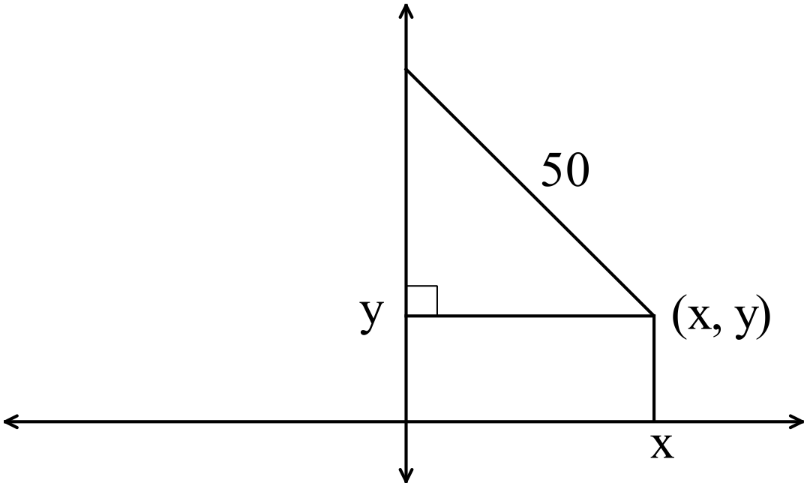

(ii) Find the rate of increase of the height h of the water after 100 seconds. (4 marks)

Question 13 (13 marks)

(a) A particle starting at O, moves in simple harmonic motion with a frequency of 2 oscillations per second and has an amplitude of 10 cm.
What is the maximum speed of the particle and what is the displacement of the particle when this occurs? (4 marks)

(b) A tourist train starts from rest at a station P and travels on a straight track to station Q, where it stops. Between the stations the velocity of the train, km hour⁻¹, hours after leaving P is given by

(i) Calculate the distance from P to Q. (2 marks)

(ii) Find the initial acceleration. (1 mark)

(iii) Find the maximum speed of the train. (1 mark)

(c) Initially, a particle, has a displacement of 1m from O and is travelling with a velocity of The acceleration of the particle is given by
Find the displacement x(t) at any time t in terms of t. (5 marks)

Question 14 (17 marks)
(a) The vector is perpendicular to plane P which is known to contain the point .
(i) Determine the Cartesian equation of the plane P. (2 marks)

(ii) Show that the plane contains the point B(-2,-1 2). (1 mark)

(iii) Determine a vector equation of a line that is perpendicular to plane P. (1 mark)

(b) Describe the set of points defined by (3 marks)

(c) An eagle’s nest is at P(170,-75,163). The eagle sees a crow at the nest and flies from its current position of (10, 5, 3) straight towards the nest with a velocity of .
(i) Determine how long the eagle would take to return to the nest if it does not change its direction or its speed. (2 marks)

The crow takes 15 seconds to realise the eagle is coming back to its nest.

(ii) How far is the eagle away from its nest at this time? (3 marks)

The crow takes off from the eagle’s nest with a velocity of and does not change direction. The eagle instantaneously changes direction and heads for the crow’s path with a velocity of .

(iii) Determine how many seconds it takes the eagle to catch up to the crow after the crow left the nest and the position vector of the point where this occurs. (5)

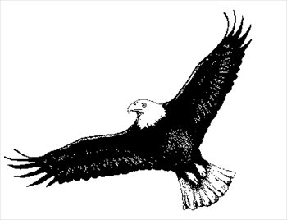

Question 15 (8 marks)
Given
(a) find expressions for
(i) (1)

(ii) (1)

Hence, use de Moivre’s theorem to show that
(iii) (1)

(iv) (1)

(b) Use your answers in (a) to show that (4 marks)

Question 16 (7 marks)

(a) Given , use a Calculus method to show that

HINT: Let (5 marks)

(b) Find N when t = 20. (2 marks)

Question 17 (17 marks)

(a) A set of 50 samples of size 15 are taken from a population that has a frequency distribution as shown in the graph below.

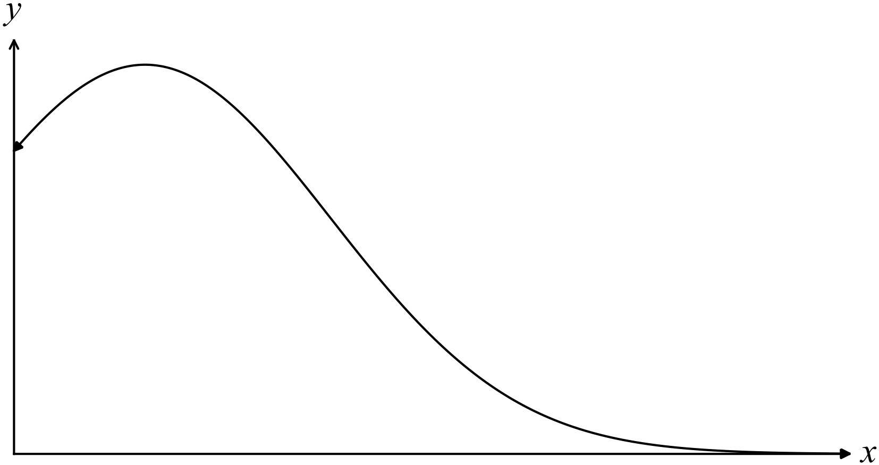

(i) Graph the shape of the distribution of the means of the samples on the set of axes below. (1 mark)

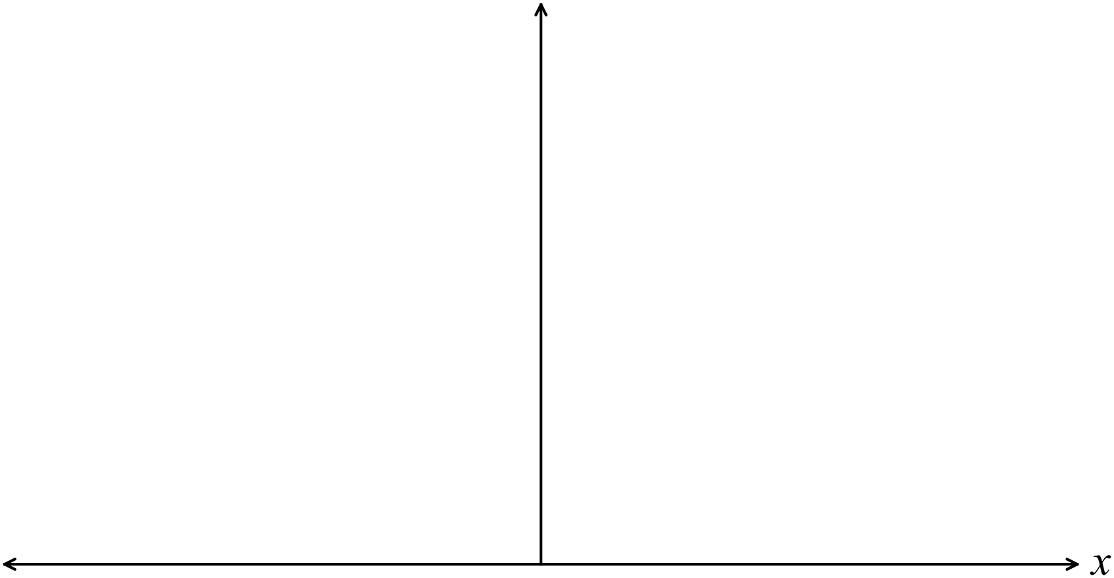

(ii) Explain why you have chosen the graph in (i). (1 mark)

(b) A company manufacturing sachets of gourmet porridge, advertised as containing 40 grams, actually manufactured sachets that were normally distributed with an average weight of 41 grams and with a standard deviation of 1 gram.

A sample of 100 sachets were randomly selected and weighed.

(i) What is the expected mean and standard deviation of the weight of the 100 sachets?
(2 marks)

(ii) What is the probability that the mean weight of the sample is less than the advertised weight of 40 grams? (2 marks)

(iii) The machine dispensing the contents into the sachets sometimes needed adjusting.
A sample of 9 sachets was randomly selected and had a mean weight of 41.8 grams.

Is the sample significantly different from the normal manufacturing standards at the 95% level? (3 marks)

(c) A random sample of 100 taken from a large batch of Brand X AA batteries had a mean life of 4.8 years and a standard deviation of 1.5 years. The mean lives of the batteries are normally distributed.

Determine the 95% confidence limits for the mean life of the batch of batteries. (3 marks)

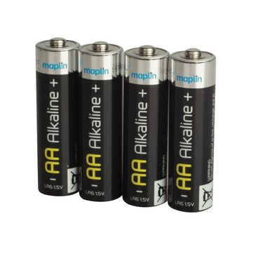
(d) A random sample of packaged blueberries is to be sampled from a population of 10,000 packets of blueberries in a cold room waiting to be shipped to suburban stores. The standard deviation of the packages is 10 grams.

How large should the sample be to be 99% confident the mean of the sample is within 8 grams of the population mean? (5 marks)

End of questions
Additional working space

Question number(s): ……………………

Additional working space

Question number(s): ……………………

